# Thermal Analysis

Mosfet

Pmos,tot  = Pconduction + Pswitching = 0.8442 W

For normal conditions, let choose ambient temperature as 25oC.

If no heatsink applied, the junction temperature is:

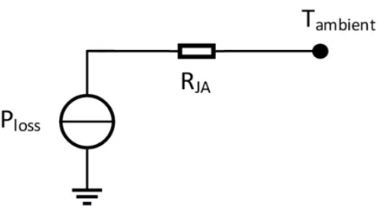

Tjunction = Tambient +PlossRJA = (25 + 0.8442 * 80) = 92.54oC

Our mosfet can operate in this temperature and even if its current rating decrease, it is still can supply maximum input current when it is on. So, heat sink is not used for mosfet.

Diode

PDiode,tot  = Pconduction + Pswitching = 7.17W

For normal conditions, let choose ambient temperature as 25oC.

If no heatsink applied, the junction temperature is:



Tjunction = Tambient +PlossRJA = (25 + 7.17* 50) = 383.5oC

As seen in the result, diode dissipate high energy and heatsink has to used for diode to operate in its temperature region.

For heat sink HSE-B20380-040H-01 selected and its specialty seen in the graphs.

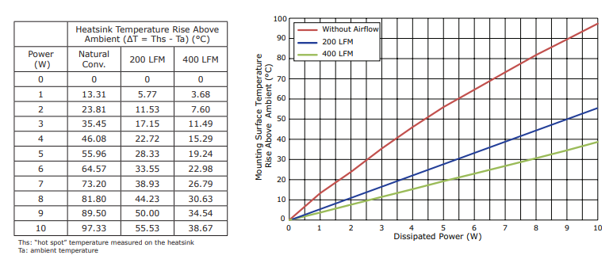

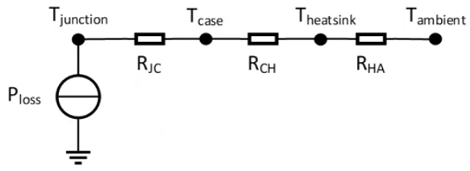

Tjunction = Tambient +∆Theatsink + PlossRJC = (25 + 81.8 + 7.17*2) = 121.14oC

Resulting temperature is not low but diode can operate at this temperature. Since our peek current is not close to the maximum ratings decrease in the max current ratings at the high temperature don’t affect the converter.